BigCommerce Changes Documentation

# Table of Contents

**Table of Contents 1**

**Accessing the file for the navigation bar 2**

**Adding an item to the Navigation Bar 3**

**Removing the Shopping Cart Button 4**

**Removing Add To Cart Buttons 5**

Easy Button on SOP Lagoon 5

Not So Easy Buttons on Products 6

## 

## Accessing the file for the navigation bar

Assuming that you are already in the “Stencil File Editor” if not try this [link](https://store-3bgo97pxit.mybigcommerce.com/manage/file-editor/c170a420-8360-013a-109f-62484650b759/c1a86c70-8360-013a-109f-62484650b759/862236d0-f1a7-013b-7d1a-2672c4534db5).

The file for the navigation bar is called “header.html‘ just for context.

The file path to get there:

1. templates (folder)
2. components (folder)
3. common (folder)
4. header.html

File path is something like: “**templates/components/common/header.html**” if that helps.

Image for reference:  
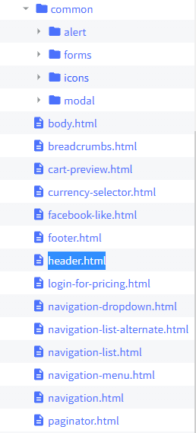

## Adding an item to the Navigation Bar

**File Location: header.html**

Whilst in the header.html file, after line 763 you can insert a new list item and that will append an item to the end of the navigation bar after “Contact Us”.  
  
Reference Picture:

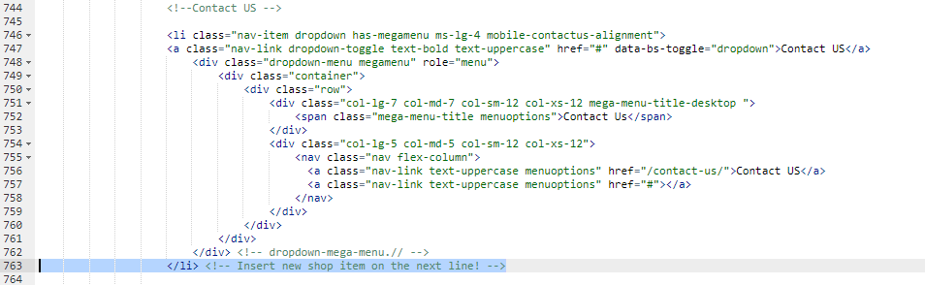

Example to add the word “Shop” that links to the Shopify store [here](https://48bb38.myshopify.com/password):

<li class="nav-item text-uppercase text-bold active ms-lg-4"> <a class="nav-link" href="<https://48bb38.myshopify.com/password>">Shop </a> </li>

Would go on line 764 or 765

Reference Picture:

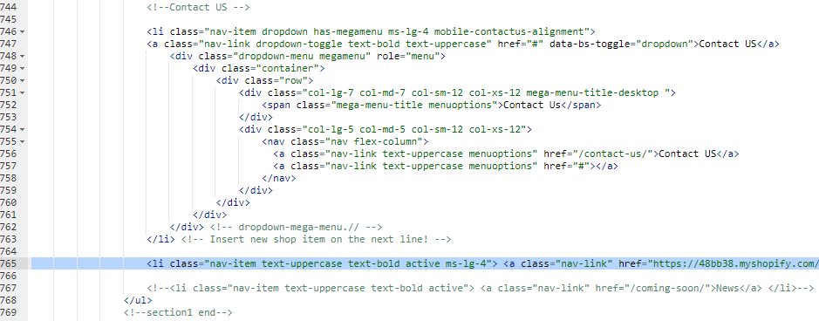

## Removing the Shopping Cart Button

**File Location: header.html**

Lines 820 - 843 marks the cart item within the navigation bar.

Reference Picture:

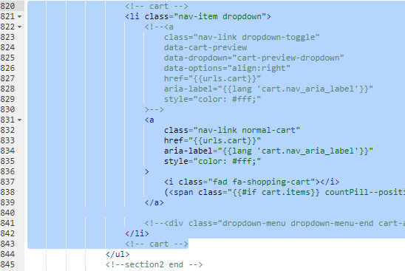

Deleting this list item will remove the Shopping Cart icon (hopefully)

To delete just remove all lines from 820 to 843.

## Removing Add To Cart Buttons

### Easy Button on SOP Lagoon

SOP Lagoon is the only product with an Add To Cart button when not logged in.

Reference Picture:

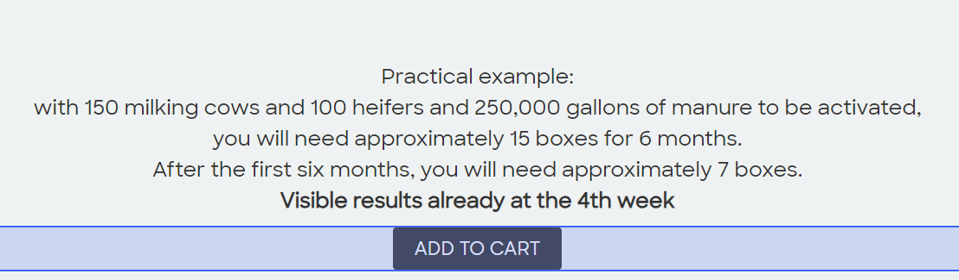

To remove the button you can just use the Page Builder and delete it.

To access the Page Builder try this [link](https://store-3bgo97pxit.mybigcommerce.com/manage/page-builder?channelId=1&redirectIframeUrl=?showStore=yes).

To get the Lagoon page from the Home page of the Page Builder just go into preview mode and then click on the links until you end up at the Lagoon page.

Clicking Path: Our Solutions → Dairy & Livestock → SOP Lagoon

Then switch back to Design mode by clicking “Design” on the top nav bar.

Reference Picture:

### 

### Not So Easy Buttons on Products

**File Location: add-to-cart.html**

How to Access the file:

1. templates (folder)
2. components (folder)
3. products (folder)
4. add-to-cart.html

File path: templates/components/products/add-to-cart.html

On line 148-157 there is a class called “form-action” which is the class for the “Add to Cart” button when logged in.

Reference Picture: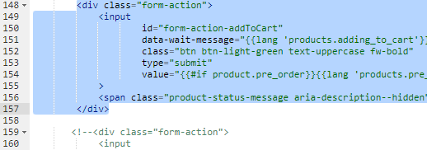

Removing this class might remove the button? (like a 50% chance of success)